Requirement
SuiteCommerce Standard project.
We need to add a register here link or button in the native login page. Native register button is not there since the password is site protected, only login is available.
This button will take the customer to an external form, a different URL. This external form will create a new Lead (without access). We will need to build this form. This form will need to expose:
- First Name
- Last Name
- Company
- Phone Number
- Street Address (Problem netsuite’s have multiple fields for this)
- Email Address
- Password
- Dealer No. (netsuide ID custentity_dealer_no)

Then we do not need to redirect the customer back to the store, just display a confirmation message on the form created. Can be green in the form itself, like when you subscribe to the newsletter.

We can’t use Advanced Sign up.

More notes:
- Password protect the entire site
- Do not show the native registration form (Doable somehow on SCA) (Hide it on login page and have a link to the external custom form).
- Create an external form for customer registration (Do they need that registration to happen on an external website or not? We can use a restlet to be called by the external site, to create a new lead and push it back to netsuite).
- Add a link to that form in the login page *
- Once submitted, a new Lead will be created without access
- A message will be displayed providing information to the user (where is this message displayed?)

* The URL will be similar to this one: https://4890397.extforms.netsuite.com/app/site/crm/externalleadpage.nl/compid.4890397/.f?formid=1&h=AAFdikaIiOfSHO9_ba90PKAUQOyGDRYbIWDOKSylHzM-P8ltAlU&redirect_count=1&did_javascript_redirect=T

We can add HTML to improve the look and feel to match the CAT site.
Clients deadline is middle of August. This customization is a requirement for launch and the client needs to be live by 9/6/23.

Solution
Native solution.
Go to Setup -> Marketing -> Online custom forms -> New, nos abrirá:
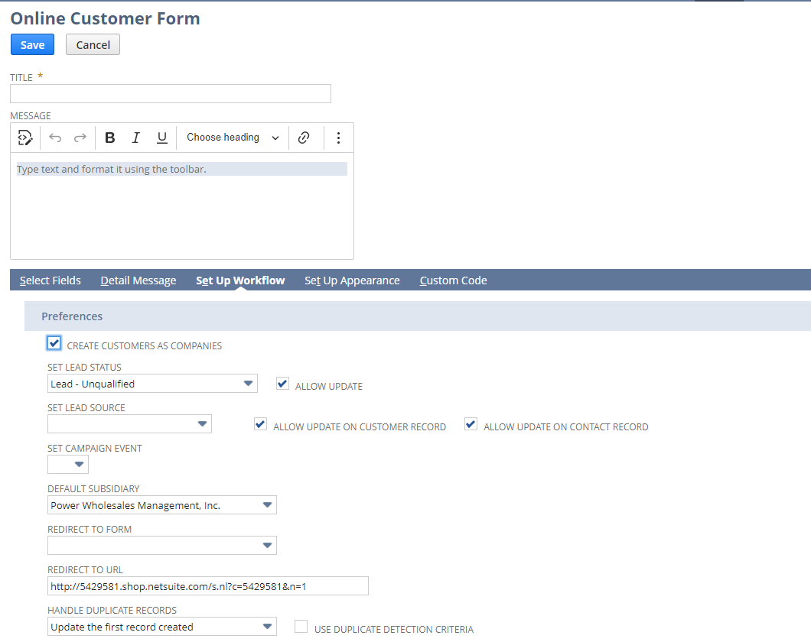
Aquí agregamos los datos que necesitamos (login password también). En la sección de “set up workflow” le seleccionamos en “set lead status” -> Lead – Unqualified, así, este form cuando haces submit te va a ejecutar la creación del lead.

https://6785294.extforms.netsuite.com/app/site/crm/externalleadpage.nl/compid.6785294/.f?formid=2&h=AAFdikaIOeH4AOxYqmM9K_IlU0LJYPZSXtqUgrbUGpCWIiglT68&redirect_count=1&did_javascript_redirect=T
Producción de norscot.
Luego de ahí creas el form. Te va a dar un href una vez creado el form, que vas a usar como landing page.
Ese href lo usamos para la Landing page desde configuration record.

Custom code
En la sección custom code, podemos agregar un archivo para que ejecute si pasan ciertas acciones del form.
Chequear la documentación de “custom code” en: https://tstdrv2509281.app.netsuite.com/app/help/helpcenter.nl?fid=section_n2882662.html&whence=
También usar el ejemplo: https://suiteanswers.custhelp.com/app/answers/detail/a_id/75109/loc/en_US
Esto puede ser como un client script de JavaScript:
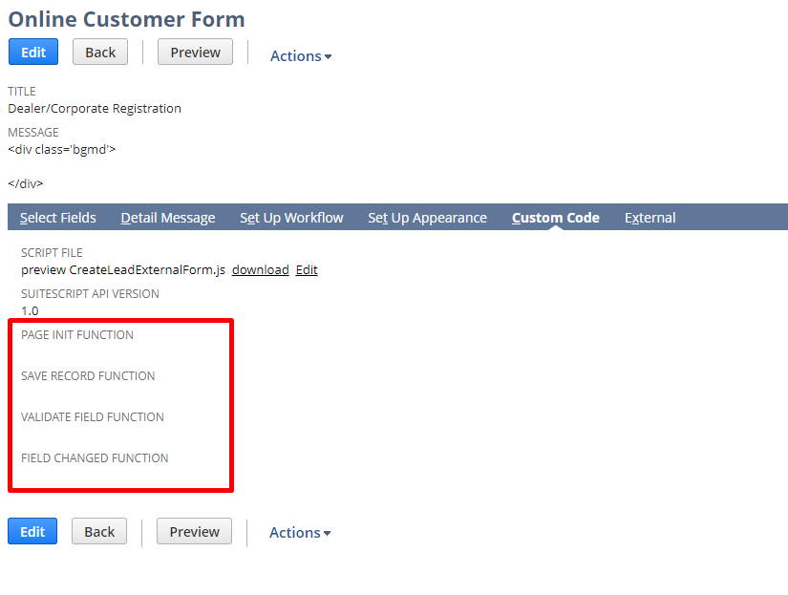
Ahí vemos que tiene funciones pageInit, saveRecord, validateField y fieldChanged.

Agregué mi función saveLead ahí y anduvo:
function saveLead(){
// var field = nlapiGetField('type');
// console.log('hola' + JSON.stringify(field));
return true;
}

